**Elucidating the Mechanisms of Ion Transport Dependent Scaling in Bipolar Membrane Electrodialysis**

Yuqin Nia,b, Hong Liua,b Qianhong Shea,b,*

1. School of Civil and Environmental Engineering, Nanyang Technological University, Singapore 639798, Singapore
2. Singapore Membrane Technology Centre, Nanyang Environment & Water Research Institute, Nanyang Technological University, Singapore 637141, Singapore

* Corresponding Author. Email address: qhshe@ntu.edu.sg

Abstract

Bipolar membrane electrodialysis (BMED) is a promising technology to treat seawater brine, enabling simultaneous acid and base production along with brine dilution. However, the presence of divalent cations, such as Ca2+ and Mg2+, can lead to scaling through reactions with hydroxide ions (OH-), posing a significant operational challenge. This study provides a mechanistic investigation of scaling formation in BMED, with a particular emphasis on their strong reliance on ion transport. Scaling was observed in salt chamber (SC) and base chamber (BC), as well as on membrane surfaces – specially on both sides of the cation exchange membrane (CEM) and the anion exchange layer of bipolar membrane (BPM). Initially, divalent cations migrated through the CEM and reacted with excess OH⁻, resulting in deposit formation on the CEM facing BC and in BC. The deposits reduced the effective membrane area, increasing the local current density. Once the local current density exceeded the limiting current density, water splitting occurred to generate additional OH-. OH- leaked into SC and reacted with residual divalent ions, causing further precipitation in the SC and on CEM facing SC. Scaling on CEM triggers water splitting to aggravate scaling in SC. Additionally, scaling on BPM was attributed to the interaction between divalent cations and the locally elevated OH- concentration. Overall, this finding underscores the critical influence of ion migration and local electrochemical environment conditions on scaling behavior.

**Keywords:** Bipolar membrane electrodialysis (BMED); Seawater brine treatment; Scaling formation

**Synopsis**

The ion transport (including ion migration, water splitting and OH- leakage) induce scaling in the solutions and across different membrane interfaces during BMED process.

TOC Graphic

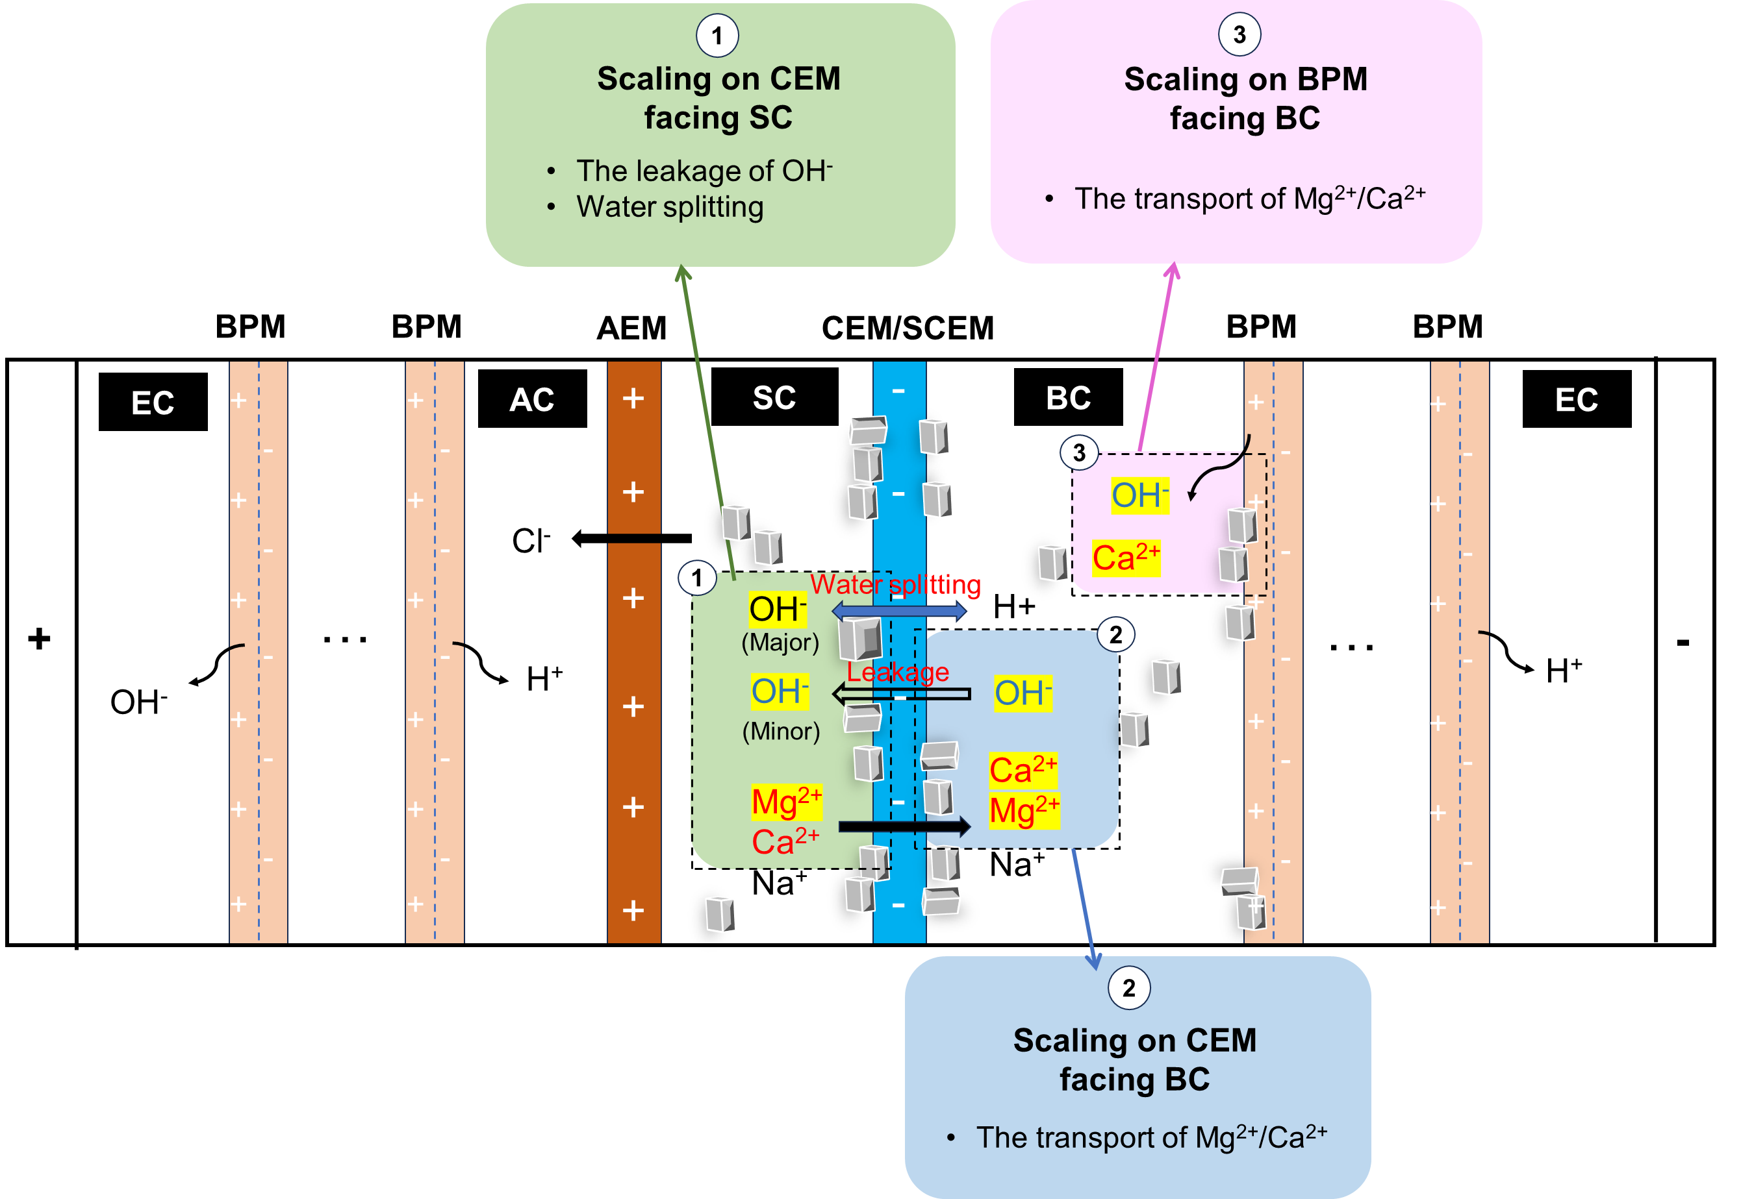

1. Introduction

In conventional chemical processes, high-salinity wastewater often arises as a byproduct of acid-base neutralization reactions. The direct discharge of brine solutions not only damages the environment1-3 but also leads to the loss of valuable resources.2, 4-6 Therefore, the effective treatment of such waste brine solutions has become an urgent and critical issue. Among various treatment methods, electrodialysis (ED) has been widely employed to concentrate brine solutions, facilitating subsequent crystallization into solid salts.7-9 However, the economic viability of salt recovery via ED is not always favorable.10??? To address this limitation, bipolar membrane electrodialysis (BMED) has been developed as an advanced electrochemical separation technology that combines the principles of ED with the unique properties of bipolar membranes (BPMs).10-13 This approach enables the production of acids and bases from salt solutions, providing an efficient and environmentally sustainable alternative to conventional chemical processes. BMED has been applied in various biological and chemical industries.14-17 Many studies have shown that BMED has the potential to produce high-purity acids (e.g., HF,18 HNO3,10 HCl,19 H2SO4,20 H3PO4,21 acetic acid,22 citric acid23) and bases (e.g., NaOH, 21, 24 LiOH19) from salt solutions.

Scaling on ion exchange membranes (IEMs) is an urgent problem in BMED. 25, 26 Scaling adversely affects BMED performance by reducing ion flux, increasing membrane resistance, and elevating energy consumption.26-28 As scaling progresses, it can cause irreversible damage to membranes, especially increasing the risk of membrane rupture.29 In-depth research on the causes of scaling can provide effective strategies to alleviate or avoid scaling, thereby achieving high efficiency. Previous studies concluded that scaling is related to the solution composition, process parameters.30-34 Bazinet, et al. 35 and Wang, Yang and Cong 27 found scaling on cation exchange membranes (CEMs) when feeding solution contained Ca2+ and Mg2+. Casademont, et al. 36 found that an alkali feeding solution triggered scaling on CEMs. Therefore, pretreatment such as nanofiltration,37 chemical precipitation,37 ion exchange resins,19 pellet reactor 26 was introduced prior to BMED to remove scaling ions. 不用去讲pretreatment These studies informed that the presence of scaling ions (e.g., Ca2+, Mg2+ and OH⁻) in feeding solution predominantly resulted in sparingly soluble precipitates on IEMs in ED.25-27, 35 However, the transport of ions is more complicated in BMED: water dissociation happens on BPMs, and the increasing OH⁻ concentration in the base chamber is likely to result in scaling in the stack. Besides the solution composition, Mehran Aliaskari 38 concluded that flow rate and current densityplay key roles in scaling growth on BPM in BMED system. However, the research only focuses on the scaling on BPM without considering the scaling on CEMs and in chambers.

Some limitations of previous studies (e.g., only focusing on specific IEMs) result in a lack of comprehensive understanding of scaling formation across the entire BMED stack. It is essential to recognize that water dissociation and **selective** ion transport in BMED alter the ion concentration dynamically, leading to changes in local conditions that strongly influence scaling tendencies. Therefore, it is necessary to identify scaling formation in different parts of the stack. This understanding will support the development of targeted process modifications, novel membrane configurations, and advanced operational strategies to effectively avoid scaling. The objective of this study is to elucidate the mechanism of scaling formation throughout the BMED process, with a focus on the interactions between ion transport and scaling development. The influence of scaling on BMED performance and efficiency was discussed to explain the significance of the study. The scaling in the chamber and on IEMs was characterized to ensure the location where scaling took place and its composition. In the BMED process, the system parameters were monitored to explain the scaling evolution. By providing a mechanistic framework, this study offers insights into future strategies for effective mitigation and operational optimization.

1. Material and Methods
   1. Lab-scale BMED Stack and Membranes

Commercial ion exchange membranes (IEMs) were used in this study. The bipolar membranes (BPMs) denoted as CJBPM-1 were provide by Kejia Polymer Materials Technology Co., China, while the CEMs and anion exchange membranes (AEMs) denoted as CSE and ASE, respectively, were provided by ASTOM Co., Japan. The effective area of each piece of membrane in the BMED stack was 7.065 cm2.

The configuration of the lab-scale BMED stack was illustrated in **Figure S1**. The stack contained three repeating units, each consisting of one BPM, one AEM, and one CEM. An additional BPM was placed adjacent to the cathode. Titanium electrodes coated with ruthenium served as the anode and cathode. The complete assembly comprised two electrode chambers (ECs), three acid chambers (ACs), three salt chambers (SCs), and three base chambers (BCs).

* 1. **Experimental Testing Protocol**

A closed-loop circulation system was employed in the experiments.39 The setup consisted of four independent solution circuits: salt solution, base solution, acid solution, and electrode rinsing solution. A synthetic seawater brine (SWB) solution was prepared by doubling the concentration of major ions in seawater,34 with the detailed composition provided in **Table S1**. For comparison, a NaCl solution with equivalent conductivity to the SWB was used as a baseline system in the absence of scaling. The BC and AC were initially filled with 10 mM NaOH and 10 mM HCl, respectively. The electrode rinsing solution was 0.3 M Na2SO4. The volume of each solution was 0.4 L. Two peristaltic pumps, each with two pump heads (Lead Fluid, BT-600L-2 × YT15, China), were used to recirculate the solutions at a constant flow rate of 200 mL/min through the respective chambers. A constant current mode was adopted and the applied current density was maintained at 15 mA/cm² using a DC power supply (A-BF SS-L603SPD, China). Each experimental run lasted for 9 hours and was repeated at least three times to ensure reproducibility. Prior to applying the current, the system was operated for 10 minutes to remove air bubbles, ensuring complete wetting of the membrane surfaces and minimizing potential performance disturbances.

* 1. **Scaling Characterization and BMED Performance Analysis**
     1. Scaling Characterization

Field-emission scanning electron microscopy (FESEM; JEOL-7200F, Japan) and energy-dispersive X-ray spectroscopy (EDX; Oxford Instruments Aztec Standard X-max 50, UK) were employed to examine membrane surface morphology and elemental composition. Additionally, precipitated solids collected from membranes after BMED operation were analyzed using X-ray diffraction (XRD; Bruker D8) to identify crystalline phases. To assess the extent of crystalization in the bulk salt solution within the SC and BC, turbidity measurements were performed for these solutions using a laboratory turbidimeter (2100N IS, HACH), with each sample analyzed in triplicate for accuracy. 30 mL of solutions were sampled from the SC and BC before and after each experiment. .In addition to qualitative characterization, quantitative analysis was conducted to evaluate scaling severity. Ca²⁺ and Mg²⁺ concentrations in each solution were measured periodically during each testing using inductively coupled plasma optical emission spectroscopy (ICP-OES, Vio 550Max, PerkinElmer).The reduction Ca²⁺ and Mg²⁺ was analyzed to determine the mass of scaling ($m_{scaling-Ca}$, $m_{scaling-Mg}$, mg). The detailed calcuttion was shown in **Supporting Information S3**.

* + 1. BMED Performan**ce Analysis**

Key operational parameters—including voltage, current, and pH—were continuously monitored to assess BMED performance and ensure system stability. Conductivity changes in AC, BC and SC were recorded every five minutes using conductivity meters (Orion Star A212, Thermo Scientific, USA). Current and voltage data were recorded every minute using Power DC software. The pH in the AC, BC, and SC was measured by portable pH meters (Seven2Go pH/Ion Meter S8, Mettler Toledo, Singapore). The purity of acid and base (%) was calculated via Eq. 1.



Where is the concentration of acid or base (g/L) and is the concentration of impurities in acid or base (g/L).

Additionally The stack resistance ($R_{stack}$, Ω) was calculated according to Ohm’s Law with **Eq. 2**.



Where $U_{t}$ was the voltage (V) and $I_{t}$ was the current (A) at time $t$.

The stack resistance is the sum of electrode resistance, chamber resistance, and membrane resistance.34, 40 The chamber resistance ($R_{chamber}$, Ω) was calcualted by **Eq. 3**.40

Where is the number of repeating units, $A$ is the effective area of each membrane (m2). , , were the thickness of AC, BC and SC (m), $σ_{AC}$, $σ_{BC}$ and $σ_{SWBC}$ is the conductivity of AC, BC and SC (S/m).

The membrane resistance ($R_{membrane}$, Ω) was calculated by **Eq.4**.



The electrode resistance ($R_{ele}$) was 43.11 Ω tested by the setup shown in **Figure S2** and calculated from **Figure S3** (details in **Supporting Information S4**).

* + 1. Reversibility Tests of BMED

To evaluate whether BMED performance declined with membranes after removing scaling, cyclic tests were performed after doing thorough cleaning at the end of test with SWB salt solution. The stack was disassembled, and the membrane was taken out for cleaning by rinsing with DI to eliminate any residual deposits. These cleaned membranes after treating SWB were then reassembled into the stack. The cyclic tests were run with a NaCl solution and the BMED performance parameters were measured described in Section 2.3.2.

For comparison, a control test was also performed using membranes that had been operated only with NaCl solution. These membranes underwent the same cleaning procedure.

1. Results and Discussion
   1. Scaling Occurs on Multiple Locations across the Entire BMED Stack

After tests, IEMs and solutions were characterized by FESEM and turbidimeter to analyze the scaling formation and chemical composition at multiple locations of the BMED stack. When treating NaCl, the baseline salt solution, no precipitate was visually inspected using photographic evidence (**Figure 1 a1, b1, c1, d1**) and FESEM (**Figure S4 a1, b1, c1, d1**). In contrast, after BMED treating SWB, although no scaling was observed on the AEM facing SC **(Figure 1 a2, a3**), precipitates were observed on both sides of the CEM (**Figure 1 b2, b3 and c2, c3**) and the BPM facing BC (**Figure 1 d2, c3**), indicating the formation of scaling on the CEM and BPM. Moreover, compared with tests for NaCl (**Figure S5 a1 a2**), SC and BC became visibly turbid when processing SWB **(Figure S5 b1 b2)**. The turbidity of solution in the SC increased from 0.137 to 45.233 NTU and that in the BC increased from 0.112 to 29.4 NTU (**Table S2**), which also proved that suspended solids were formed during the tests.

The EDX results, which revealed the elemental distribution on membranes after BMED treatment of NaCl and SWB, were consistent with the observed scaling during operation. Since no scaling was observed on the AEM after BMED of SWB, no Mg and Ca distribution was observed (**Figure 1 a4, a5**) and the atomic ratios of carbon and oxygen (**Figure 1 a6**) was similar as the pristine AEM (**Figure S6 a2**). Compared to the pristine CEM (**Figure S6 b**), clear Ca and Mg distributions were observed on both sides of the CEM after BMED treating SWB (**Figure 1 b4-b5** and **Figure 1 c4-c5**). The atomic percentage of Mg and Ca increased from ~0 to ~9 % (**Figure 1 b6, c6**). In contrast, only Ca distribution was observed on the surface of BPM (**Figure 1 d4-d5**). 1.8% Ca was detected on the BPM facing BC while the composition of Mg remained zero (**Figure 1 d6**) compared to the pristine BPM (**Figure S6 c**), which will be discussed in detail in the next section.

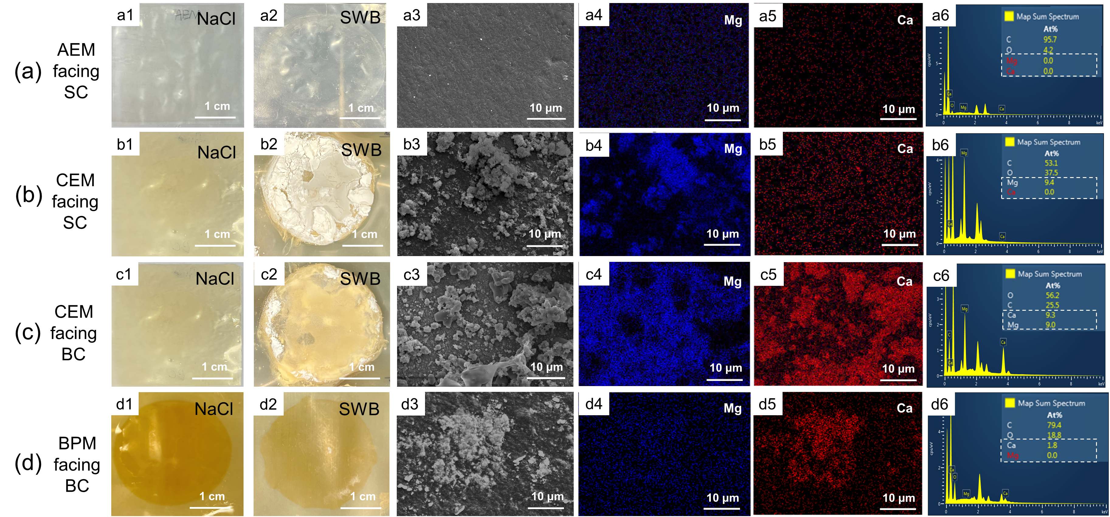

Figure 1 SEM images and EDX elemental analysis of membrane surfaces. (a) AEM facing SC: Photograph after tests in (a1) NaCl and (a2) SWB; (a3) SEM diagram; EDX elemental mapping image of (a4) Mg and (a5) Ca; (a6) EDX map spectrum. (b) CEM facing SC: Photograph after tests in (b1) NaCl and (b2) SWB; (b3) SEM diagram; EDX elemental mapping image of (b4) Mg and (b5) Ca; (b6) EDX map spectrum. (c) CEM facing BC: Photograph after tests in (c1) NaCl and (c2) SWB; (c3) SEM diagram; EDX elemental mapping image of (c4) Mg and (c5) Ca; (c6) EDX map spectrum. (d) BPM facing BC: Photograph after tests in (d1) NaCl and (d2) SWB; (d3) SEM diagram; EDX elemental mapping image of (d4) Mg and (d5) Ca; (d6) EDX map spectrum. (AC: acid chamber; SC: salt chamber; BC: base chamber; SWB, seawater brine).

Precipitates on IEMs were collected for XRD analysis to identify the type of scaling (**Figure S7**). The appeared peaks showed the presence of Mg(OH)2 in the form of brucite crystals, Ca(OH)2 in the form of portlandite, and CaCO3 in the form of calcite. The formation of Mg(OH)2 and Ca(OH)2 was due to the reaction of divalent ions and the produced OH- (Ksp = 1.8 × 10-11 for Mg(OH)2 and Ksp = 6 × 10-6 for Ca(OH)2 at 25 ℃).41-43 As there was NaHCO3 in SWB, it reacted with OH- and transferred to CO32- in SC, which further reacted with Ca2+ to form CaCO3 (Ksp = 4.7 × 10-9 for CaCO3). The above XRD results were consistent with the EDX results which showed the increase in the Mg and Ca element on membrane surfaces with scaling.

3.2 Mechanisms of Ion Transport Dependent Scaling in BMED

To gain a deeper understanding of the observed scaling behavior, this section will delve into the potential mechanisms of scaling within the BMED stack when treating SWB.

* + 1. Transport of scaling precursor ions in BMED stack

During the testing of SWB, the concentrations of scaling precursor ions (i.e., Ca2+ and Mg2+) and pH in different chambers were measured at different time to monitor their transport behavior and gain an in-depth understanding of scaling mechanisms.

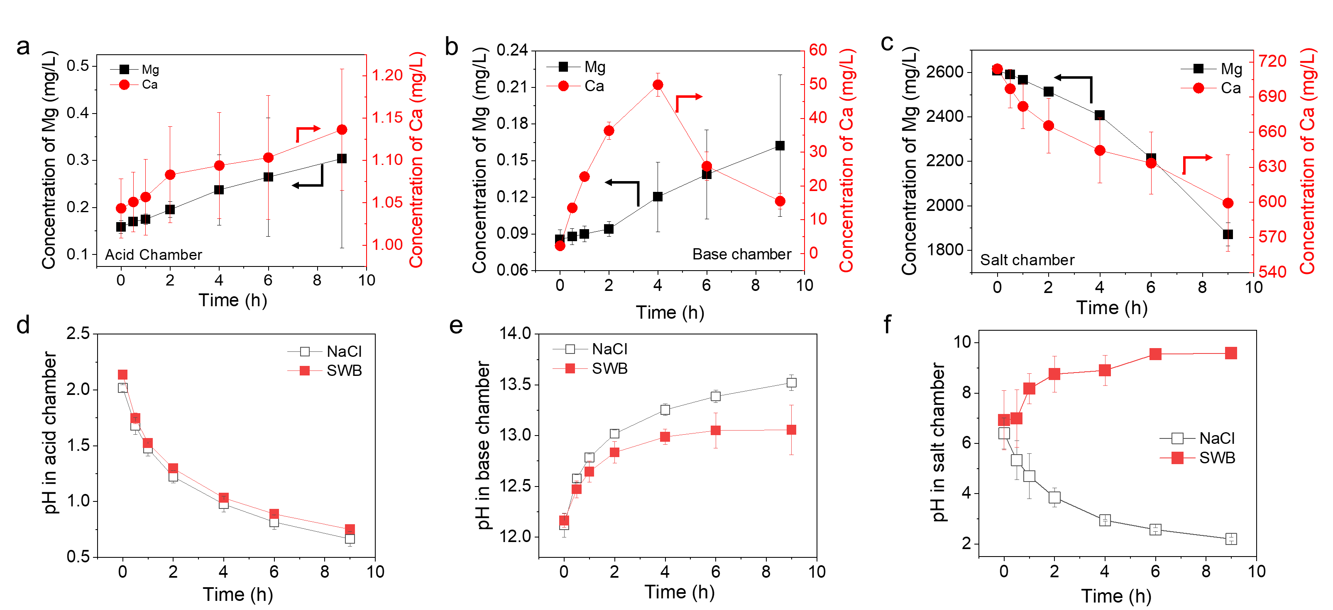

Figure 2 The concentration changes of Mg2+ and Ca2+ in (a) AC, (b) BC and (c) SC, and pH changes in (d) AC, (e) BC and (f) SC. (AC, acid chamber; BC, base chamber; SC, salt chamber)

The concentrations of divalent cations in AC and BC kept in a lower range than that in SC (**Figure 2 a, b, c**). The concentration of divalent cations slightly increased in the AC (**Figure 2 a**) and gradually decreased in the SC (**Figure 2 c**). In the BC (**Figure 2 b**), the concentration increased as well, while there was an up-down trend for Ca2+. **Figure 2 d, e** showed that the pH in AC remained below 2, while that in BC exceeded 12 throughout the BMED process for both NaCl and SWB. However, the pH in SC (**Figure 2 f**) exhibited different trends when BMED treating NaCl versus SWB. During NaCl treatment, pH gradually decreased to 2.2, whereas it increased to 9.58 when treating SWB.

To better quantify scaling, the element loss of scaling precursors was calculated (**Figure S8 a, b**). After tests, the loss of Ca gradually increased to 40.56 mg **(Figure S8 a**), corresponding to 14.15% reduction ratio (**Figure S8 b**). Similarly, the loss of Mg started as soon as the experiment began and reached 294.55 mg and reduction ratio of 28.23% at the end (**Figure S8 a, b**). Finally, the total scaling formed on membranes and in solutions increased to 335.11 mg (**Figure S8 a**). The loss can be explained by the following reactions:







The acidic condition (**Figure 2 d**) caused by water dissociation on BPM was the main reason why AEM surface was clean (**Figure 1 a2-a6**). Although there was slight leakage of divalent cations from SC to AC (**Figure 2 a**), it did not result in scaling on AEMs or in the AC. In the BC, the concentration of OH- remained high (**Figure 2 e**) due to water dissociation on BPM Moreover, the concentration of divalent ion gradually increase because they transported from SC to BC (**Figure 2b**). The concentration of Mg2+ in the BC kept in relatively low range due to **Eq. 5**. However, the concentration of Ca2+ initially increased to 49.95 ppm in 4 hours and then decreased to 15.53 ppm at the end, suggesting more severe scaling of Ca(OH)2 through **Eq. 6**. Similarly, **Eq. 5-7** occurred in the SC because of the high concentration of divalent cations (**Figure 2c**) and gradually increased pH (**Figure 2f**). The pH of SWB reached 9 at 4 hours (**Figure 2f**), and the concentration of Mg exhibited a steeper decrease at the same time (**Figure 2c**). Scaling in different parts of the stack will be discussed in detail in the following sections.

* + 1. Heterogeneous Scaling on Both Sides of CEM Surface

According to the membrane morphology detection, scaling would take place on both sides of the CEM. Each region demonstrated unique scaling behaviors influenced by local ion transport, OH⁻ generation and leakage.

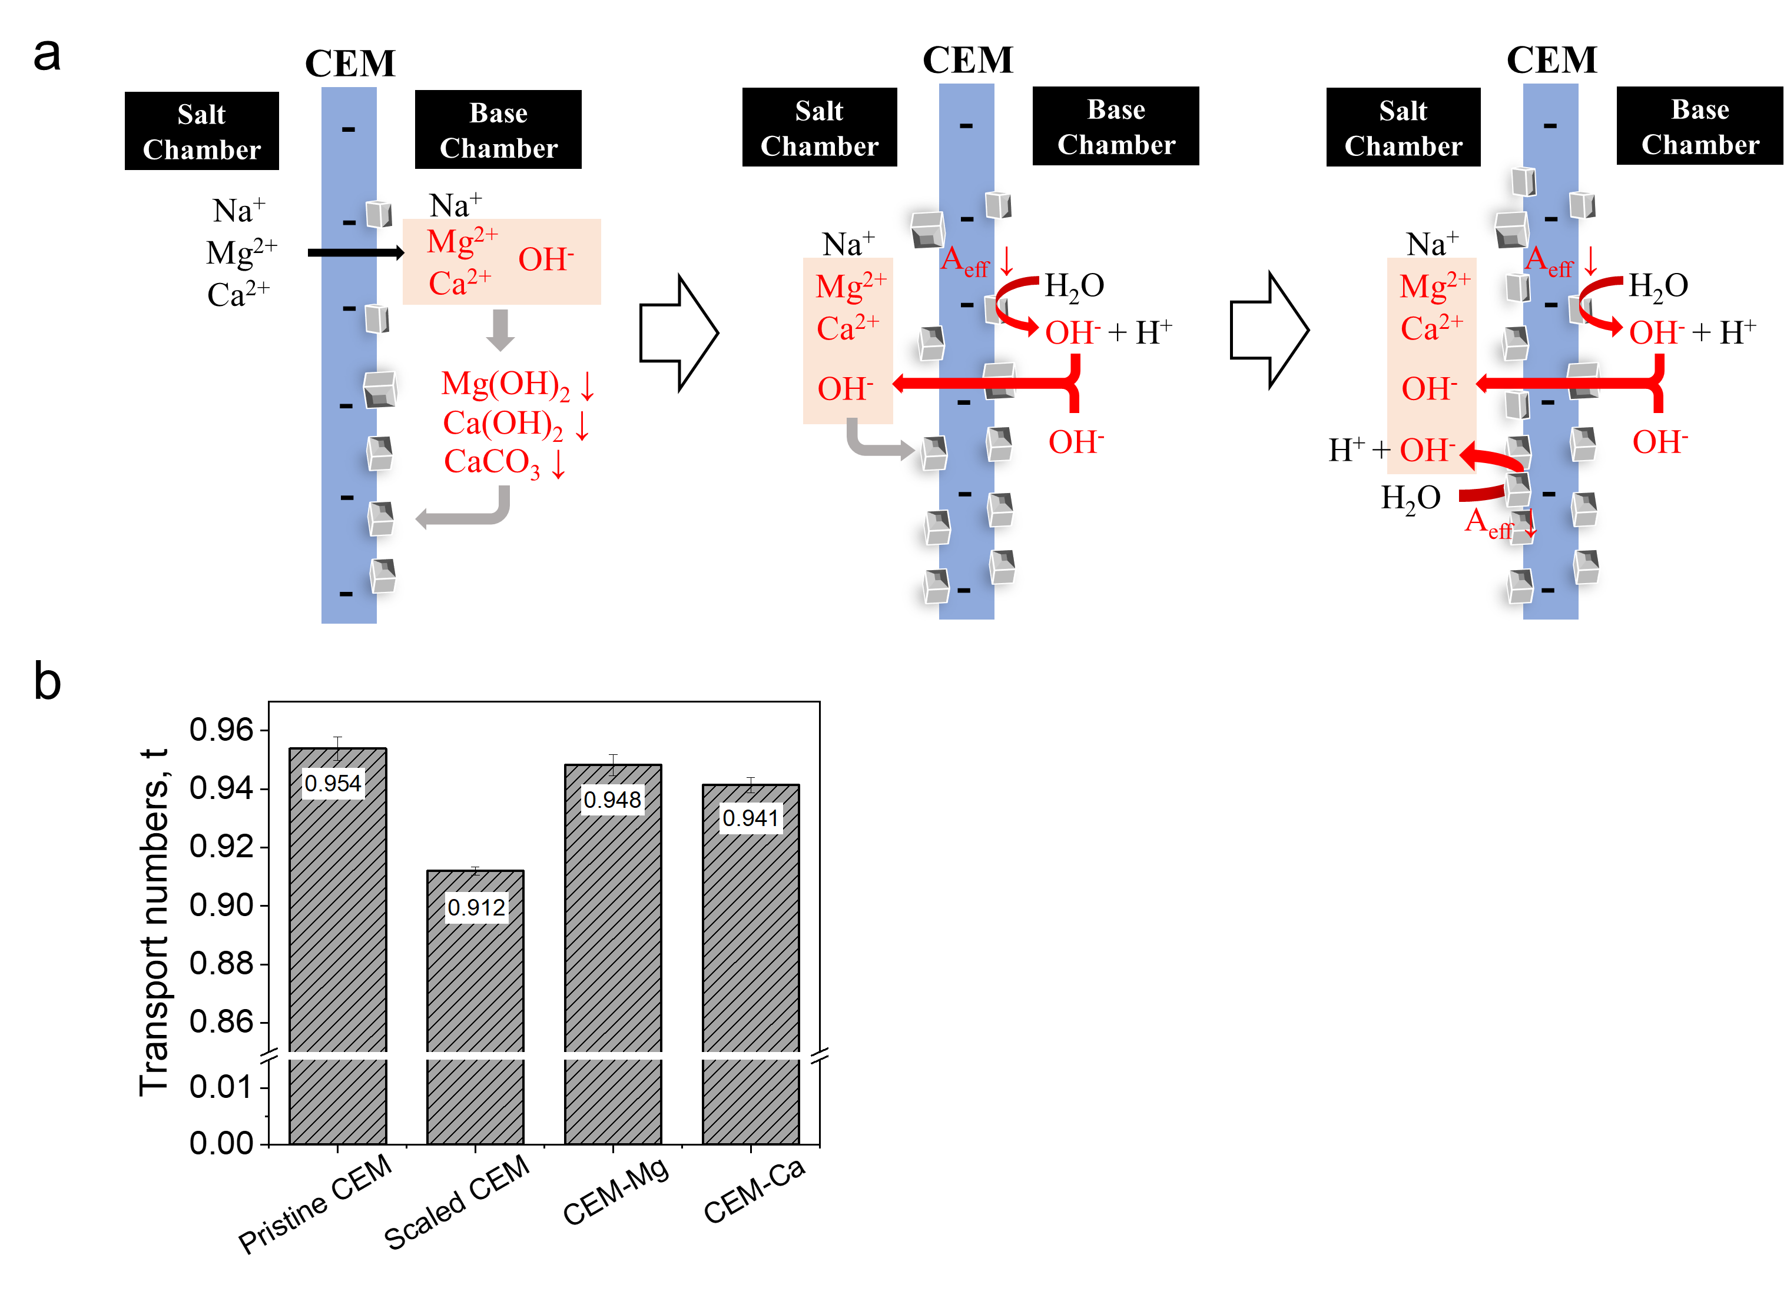

Figure 3 (a) Schematic diagram of scaling formation mechanisms on CEM (Aeff, effective membrane area).(b) The transport number of different CEMs (scaled CEM, CEM after BMED tests with SWB; CEM-Mg, CEM in Mg form; CEM-Ca, CEM in Ca form) (details in Supporting Information S10 and Figure S9)

As shown in **Figure 3 a**, once the test began, cations (i.e., Ca2+ and Mg2+) transported across the CEM from SC to BC under the electric field. At the same time, the OH- ions generated from the BPM transported to the interface of CEM/BC. When Ca2+, Mg2+ and OH- appeared on the surface of the CEM facing the BC, Mg-based precipitates formed on CEM due to lower solubility product, while Ca2+ was more likely to leave the CEM. The surface of CEM became partially covered with precipitates (**Figure 1 c2**), which reduced the effective membrane area available for ion transport. Under the constant current mode, the ion flux through the uncovered membrane region must increase to sustain the ionic current, so the local current density on the uncovered area increased.31, 34 When the local current density exceeded the limiting current density, water splitting occurred at the interface of CEM/BC.31, 34 The occurrence of water splitting generated H+ and OH- to carry current.34 OH- leaked through CEM and accumulated at the interface of CEM/SC as OH- ions have a high mobility.44, 45 The phenomenon can be proved by the different trends of pH changes in the SC between BMED using NaCl and SWB. When no scaling occurred, the pH of SC decreased, while pH of SC for BMED using SWB kept increasing (**Figure 2f**). Subsequently, the OH- reacted with Ca2+ and Mg2+ at the CEM surface facing SC. With the experiment proceeded, the scaling further decreased the effective membrane area, thereby inducing water splitting on CEM facing SC as well.32, 34 Then OH- generated due to water splitting further reacted with divalent cations and formed scaling. Eventually, a large amount of scaling was formed on CEM surface facing SC (**Figure 1 b2**), which was consistent with the scaling-enhanced scaling mechanism in previous research.34 Besides water splitting, the leakage of OH- across the CEM from BC to SC was also a potential reason. The leakage of OH- through CEM was reflected by the transport number (details in **Section S10**). The counterion transport number of the pristine CEM was 0.95 (**Figure 3 b**), indicating the leakage of OH- existed throughout the experiment. Additionally, the transport number of counter-ions of scaled CEM decreased to 0.91, indicating scaling also enhanced OH- leakage. The increase of leakage might result from the deformation of CEM, since there was no gasket covering the entire membrane. Moreover, the decreased Donan exclusion might also increase the leakage. Gou, et al. 46 found that the high binding energy between Ca2+ and fixed charge group of CEM (RSO3-) enabled part of Ca2+ retained in the membrane channel. It was consistent with the result in **Figure 3 b** that the transport number of CEM (Ca2+ type) and CEM (Mg2+ type) were a little lower than that of pristine CEM (Na+ type). When divalent ions retained in membrane channel, the fixed charges were occupied and the Donnan exclusion was weakened and allowed the transport of co-ion (OH-) more easily.

* + 1. Heterogeneous Scaling on the AEL surface of BPM

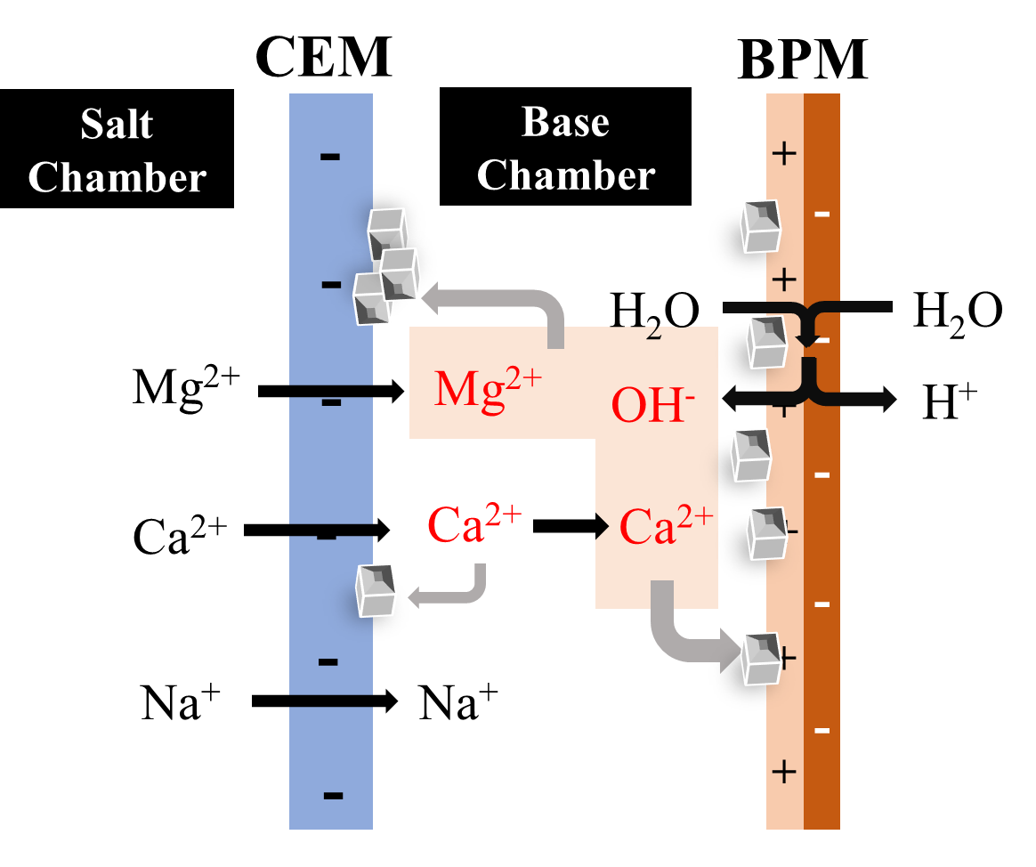

Figure 4 Schematic diagram of scaling formation on BPM

**Figure 4** shows the scaling mechanism on BPM. Cations can transport through the BC to the BPM surface facing the BC. Once the divalent cations reached the interface of BPM/BC, scaling was generated due to the high OH- concentration at the BPM surface.47 For the divalent ion transport, cations firstly transported through CEM from BC to SC. When Mg2+ reached the interface of CEM/BC, most of Mg2+ precipitated directly on CEM because of the relatively low solubility product (Ksp = 1.8 × 10-11).43 It was difficult to continue to transport in the BC and reached the interface of BPM/BC, which could also be reflected by the low concentration of Mg2+ in the BC (**Figure 2 b**). Thus, Mg-based precipitates was not found on BPM surface (**Figure 1 d6**). However, the initial increase of the concentration of Ca2+ in BC (**Figure 2b**) shows the accumulation of Ca2+ in BC, indicating that Ca2+ can reach the BC/BPM interface under electric field. With the increase in the concentration of Ca2+ and OH- at the interface, more severe scaling occurred on BPM surface as indicated by the decrease in the concentration of Ca2+ (**Figure 2b**). This is consistent with the morphology results that the composition of deposits on BPM surface was Ca (**Figure 1 d5, d6**)

* + 1. Bulk crystallization in salt solution and base solution

Scaling in the bulk solution can be divided into homogeneous scaling and heterogeneous scaling. The homogeneous scaling referred to the direct crystallization within the bulk solution. When the concentration of scaling ions (Ca2+, Mg2+, OH- and CO32-) exceeded their solubility limits, scaling formed in the bulk solution.

During BMED, cations transported from the SC to the BC, resulting in the increase of cations with time (**Figure 2 b**). Simultaneously, the concentration of OH- continuously increased due to water dissociation (**Figure 2 e**). The accumulation of divalent ions and OH- collaboratively promoted homogeneous scaling. As shown in **Figure 2 b**, the concentration of Mg2+ remained below 0.23 ppm because of the high concentration of OH- and low solubility products. The concentration of Mg2+ needed to less than 4.32 ppb in the BC to avoid precipitating (Ksp = 1.8 × 10-11 for Mg(OH)2 at 25 ℃), 30, 43 so Mg2+ in the BC was prone to form homogeneous precipitates. Similarly, the concentration of Ca2+ exhibited a rise followed by a decline. After 4 hours, the concentration of Ca2+ reached 1.24 mM and that of OH- reached 0.098 M, so the solubility product exceeded the solubility product constant (Ksp = 6 × 10-6 for Ca(OH)2 at 25 ℃). 30, 43. The sharp decrease of Ca2+ also proved that Ca-based precipitates continuously generated in the solution.

In the SC, the leakage of OH- and OH- from water splitting on CEM resulted in the increasing concentration of OH- (**Figure 2 f**). It facilitated the reaction of OH- with abundant divalent ions in the SC (**Figure 2 c**). In the SC, the concentration of OH- increased with time and the pH reached 9 at 4 hours (**Figure 2f**), accompanied by the sharper decrease in the concentration of Mg2+ (**Figure 3c**). After 4 hours, the concentration of Mg2+ reached 2.406 g/L and that of OH- reached 0.038 mM. The solubility product exceeded the Ksp, illustrating the abundant deposit formation after 4 hours.

Another scaling mechanism involved scaling that initially formed on the surface of IEMs and then detached into the bulk solution.30, 31 The surface of IEMs was smooth, and scaling grew on the membrane surface. Scaling was easy to detach from the IEM surface, which resulted from the decrease of voltage (**Figure S10**) . When a new scale layer grew, the voltage increased again (**Figure S10**). Once the scaling shredded from surface to the bulk solution, these particles not only contributed to visible turbidity but can also act as nucleation seeds, accelerating further crystallization in the solution.48

* 1. Scaling Significantly Causes BMED Performance Decline

**3.3.1 Scaling Reduces Produced Acid-Base Concentration and Purity**

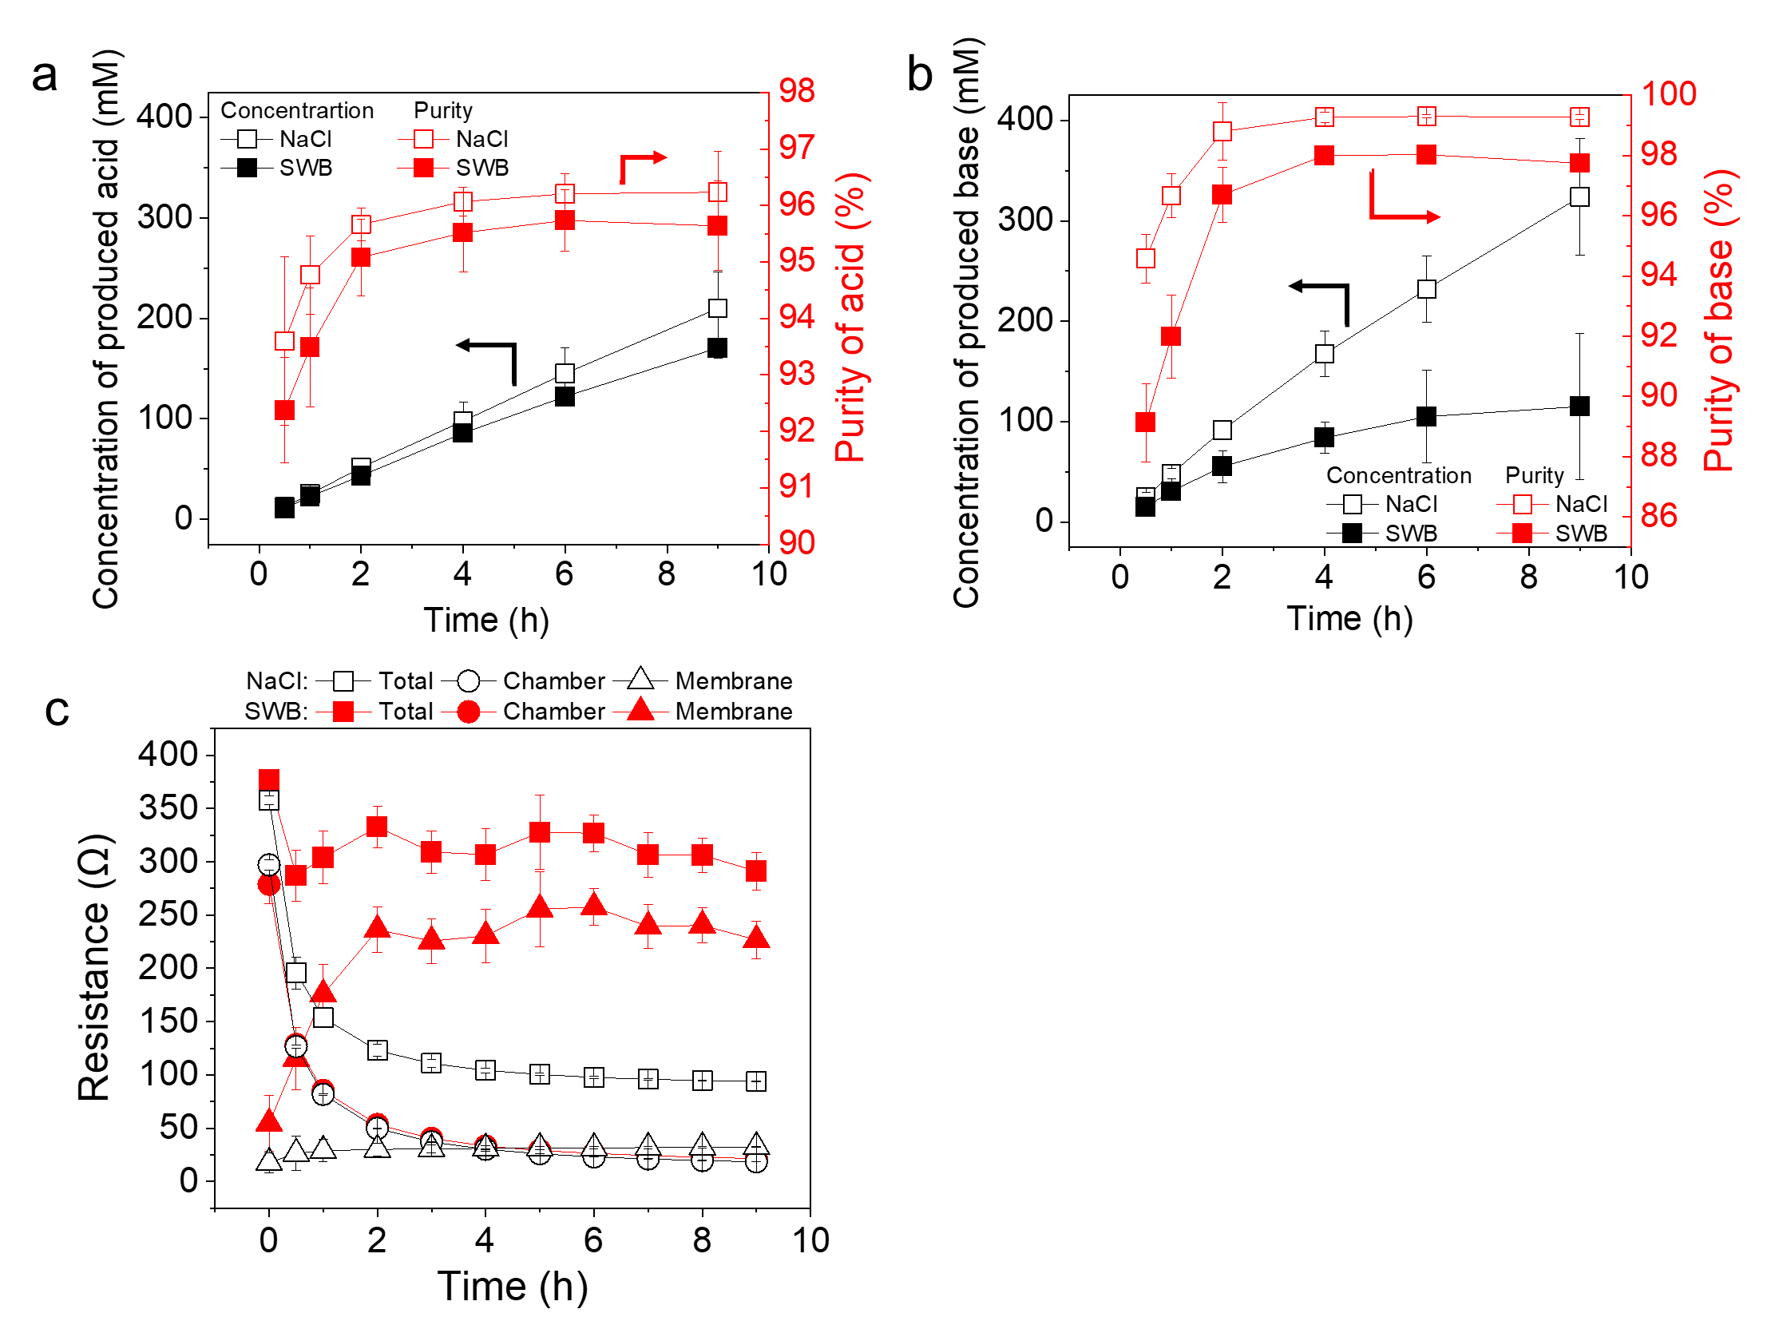

Figure 5. BMED performance change during treating NaCl and seawater brine (SWB). (a) Concentration of produced acid; (b) Concentration of produced base; (c) Variation of stack resistance, chamber resistance and membrane resistance during BMED treating different solutions.

Scaling significantly decreased the BMED performance, including the concentration of acid and base products (**Figure 5a and 5b**), the system resistance (**Figure 5c**), and energy consumption (**Figure S12**). As shown in **Figure 5a, the concentration and purity of produced acid decreased when BMED treating SWB. This decline was more significantly in base production (Figure 5 b).** While the produced base concentration during baseline testing increased nearly linearly with the operating time, the base concentration during treating SWB seemingly reached a plateau after 6 hours (**Figure 5 b**). The concentration of produced acid was lower than that of base for NaCl, while the trend is reversed for SWB. The decayed acid-base production performance and different trends during testing with NaCl and SWB are due to multiple reasons associated with scaling. During BMED using NaCl, no scaling occurred. Due to the mobility difference,49 H+ leakage was higher than OH- leakage, thereby resulting in the higher concentration of base (~324 mM base > ~210 mM acid). On the contrary, scaling during BMED using SWB consumed generated OH-, which decreased the concentration of base. Thus, the concentration of acid (~170 mM) was higher than that of base for SWB (~115 mM). Although no visible scaling was observed on the AEM and the acid chamber (**Figure 1 a and Figure S5 b2**), the concentration of acid during SWB treatment was slightly lower than that when treating NaCl. This reduction attributed to both declined H+ production and the leakage of OH- from SC to AC. Scaling on BPMs (**Figure 1 d**) reduced the transport of water to the bipolar junction, which can decrease water dissociation.50 A decrease in water dissociation led directly to a decline in acid production. Moreover, the high OH- in SC (**Figure 2 f**) indicated that it might leak to the AC to further decrease the concentration of acid. The effect of scaling on base production was more severe. In addition to consuming OH-, scaling also reduced base production by decreasing water dissociation at the BPMs and cation transport across the CEMs. Scaling on CEMs reduced the transport of cations. The conductivity of SC solution also agreed the difference between the final concentration for NaCl and SWB. As shown in **Figure S11a**, conductivity decreased by 16.65 % and 19.02% in 9 hours for SWB and NaCl, respectively. This can be attributed to the decrease in the effective membrane area on the CEM surface as discussed above. When scaling formed on the CEM surface, the transport of ions from SC was partially blocked by scaling, and water splitting occurred to form the H+ and OH- ions to carry current, compensating the decreased transport of ions from SC to BC.

Scaling also increased the system resistance (**Figure 5c**). As shown in **Figure 5c** and **Figure S10**, the stack resistance and voltage for SWB was higher than that for NaCl throughout the BMED tests. They were extremely high at the beginning of each test and subsequently decreased to a plateau for both NaCl and SWB. The high values at the beginning can be attributed to the low conductivities of initial solutions in AC and BC (**Figure S11 b**), which resulted in extremely high chamber resistance (**Figure 5c**). As BMED progressed, the increase in acid and base conductivities (**Figure S11 b**) resulted in a sharp decrease in chamber resistance. Although chamber resistance decreased at the same rate over time for both NaCl and SWB, the membrane resistance exhibited different rates of increase. The membrane resistance for SWB increased to 226.71 Ω at the end, which was six times higher than that treating NaCl (~32.36 Ω) (**Figure 2d**). The large gap between them can be attributed to the accumulation of precipitates on the membrane surface.

Accordingly, energy consumption increased with the decreased production of acid and base and increased stack resistance. As shown in **Figure S12**, the specific energy consumption of BMED using SWB was higher than that using NaCl, i.e., 90.25 % higher for acid and 5.18 times higher for base.

**3.3.2 Scaling Posed Irreversible Effect on BMED Performance**

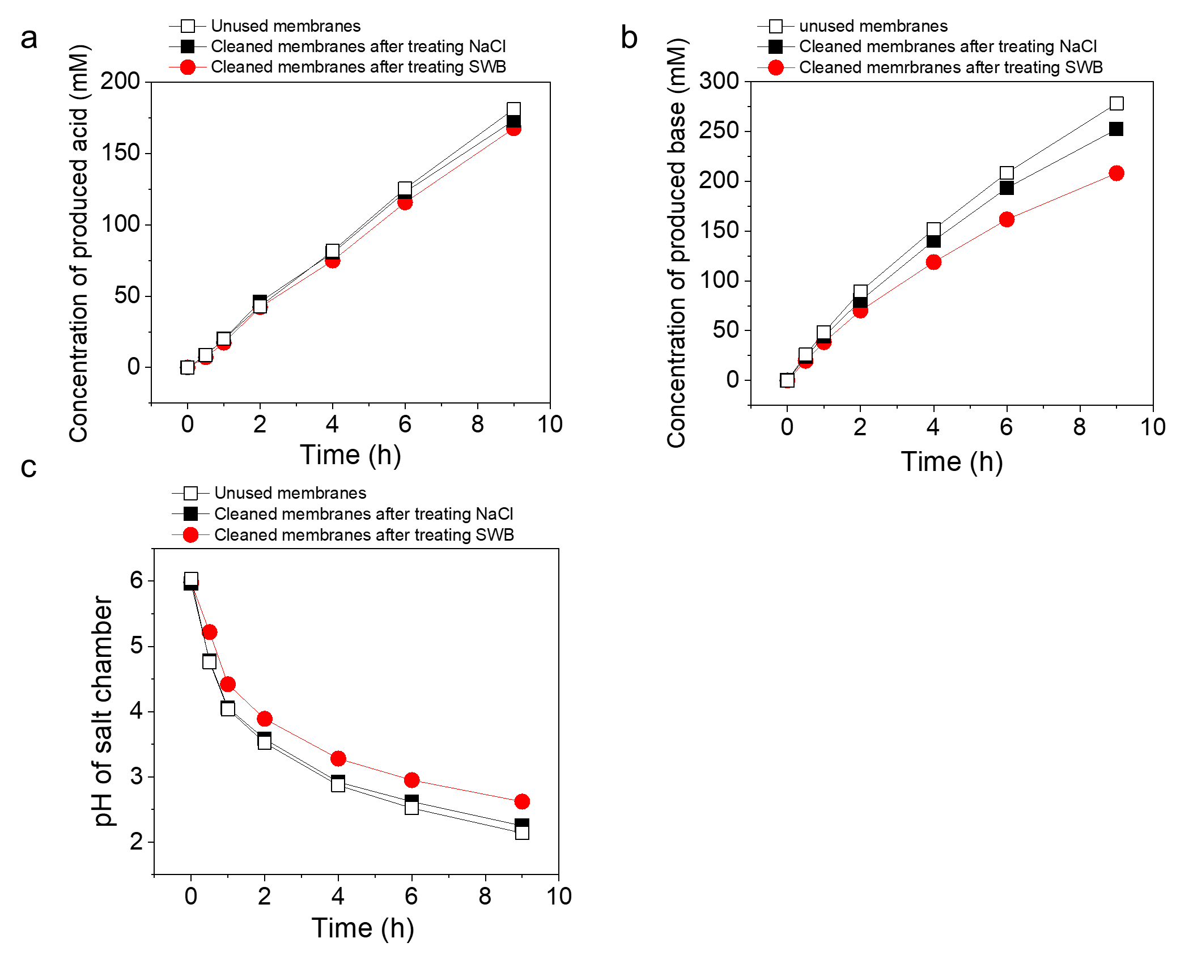

Figure 6 The cyclic tests of BMED with unused membranes, cleaned membrane after treating NaCl and cleaned membrane after treating SWB. (a) The concentration of produced acid; (b) The concentration of produced base; (c) pH change in the SC.

Scaling decrease the efficiency and lifespan of membranes and increase the requirement of cleaning frequency and maintenance.52-54 Even after physical cleaning, membranes previously exposed to scaling showed a decline in performance (Figure 6). As shown in **Figure 6**, the acid and base production decreased and the pH decrease ratio in SC declined with cleaned membranes after treating SWB. The final acid concentration was 167.59 mM (180.99 mM and 173.06 mM for unused membranes and membranes after treating NaCl, respectively), and the final base concentration decreased to 208.02 mM (i.e., 32.2 % lower compared to unused membranes) (Figure 6 a, b). The change of pH in SC (decreased to 2.14 for unused membranes, 2.25 for cleaned membranes after treating NaCl, and 2.62 for cleaned membranes after treating SWB at the end) (Figure 6 c). Scaling directly affected the ion transport in the BMED process, especially aggravating the OH- leakage. With increasing OH- transport from the BC to SC, the pH decrease in SC would be diminished (**Figure 6 c**) and the base concentration would decrease as well (**Figure 6 b**). Scaling irreversibly altered the membrane structure, changing the properties of channels or the matrix. These findings underscore scaling not only reduced ion transport efficiency but also shortened membrane lifespan.

Implication

This study provides critical insights into the mechanisms of scaling formation, particularly the strong dependance of scaling on ion transport in BMED. Scaling was identified across the whole BMED stack, including in the bulk solution and on IEMs surface (particularly both sides of the CEM and the surface CEL layer of BPM). Scaling significantly reduced the acid-base concentration and purity and caused an irreversible decline in the performance. The identification of localized supersaturation zones near membrane surfaces, driven by divalent ion transport and water splitting, highlights the need for more targeted strategies to mitigate scaling during acid and base production from SWB.

The findings suggest several actionable directions. First, since the transport of divalent ions through CEMs initiates scaling processes, incorporating upstream pretreatment to limit Ca2+ and Mg2+ concentrations is crucial. Second, water splitting caused by scaling further aggravates scaling, so managing operational parameters is essential to avoid the occurrence of water splitting. Additionally, the accumulation of deposits near membrane surfaces underscores the need for periodic removal of precipitates to preserve membrane integrity and prevent further performance decline.

All in all, this study emphasizes the importance of membrane surface conditions, ion migration pathways, and local electrochemical environments in scaling behavior—factors that should guide future membrane material development and process optimization. Continued research is necessary to develop comprehensive anti-scaling strategies, especially for BMED systems treating high-divalent-ion waters, where long-term stability and energy efficiency are critical for scaling mitigation and sustainable operation.

Associated Content

Supporting Information

Bipolar membrane electrodialysis (BMED) setup (Section S1); The composition of model seawater brine (Section S2); Stack resistance calculation (Section S3); The quantification of scaling in BMED (Section S4); Scaling formation in chambers (Section S5); Characterization of pristine IEMs and IEMs after NaCl tests (Section S6); The composition of scaling (Section S7); Specific energy consumption during BMED tests (Section S8); BMED performance changes (Section S9); pH changes in the acid chamber and base chamber (Section S10); The calculation of transport number (Section S11); The cross-section of scaled CEM and BPM(AEL side) (Section S12).

**Author Contributions**

**Yuqin Ni:** Conceptualization, Methodology, Validation, Formal Analysis, Visualization, Writing – Original Draft, Review and Editing. **Qianhong She:** Conceptualization, Methodology, Formal Analysis, Visualization, Supervision, Project Administration, Writing – Review & Editing.

**Notes**

Competing interests:

Acknowledgements

This research was supported by

Reference

1. Guo, L.; Xie, Y.; Sun, W.; Xu, Y.; Sun, Y., Research progress of high-salinity wastewater treatment technology. *Water* **2023,** *15*, (4), 684.

2. Rehman, Z.; Mushtaq, A., Advancements in Treatment of High-Salinity Wastewater: A Critical. *Int. J. Chem. Biochem. Sci* **2023,** *23*, 1-10.

3. Mohammed, A. S.; Kapri, A.; Goel, R., Heavy metal pollution: source, impact, and remedies. *Biomanagement of metal-contaminated soils* **2011**, 1-28.

4. Capodici, M.; Cosenza, A.; Di Bella, G.; Di Trapani, D.; Viviani, G.; Mannina, G., High salinity wastewater treatment by membrane bioreactors. *Current developments in biotechnology and bioengineering* **2020**, 177-204.

5. Kabir, M. M.; Sabur, G. M.; Akter, M. M.; Nam, S. Y.; Im, K. S.; Tijing, L.; Shon, H. K., Electrodialysis desalination, resource and energy recovery from water industries for a circular economy. *Desalination* **2024,** *569*.

6. Dolnicar, S.; Schafer, A. I., Desalinated versus recycled water: public perceptions and profiles of the accepters. *J Environ Manage* **2009,** *90*, (2), 888-900.

7. Valero, F.; Barceló, A.; Arbós, R., Electrodialysis technology: theory and applications. *Desalination, trends and technologies* **2011,** *28*, 3-20.

8. Strathmann, H., Electrodialysis, a mature technology with a multitude of new applications. *Desalination* **2010,** *264*, (3), 268-288.

9. Xu, T.; Huang, C., Electrodialysis‐based separation technologies: a critical review. *AIChE journal* **2008,** *54*, (12), 3147-3159.

10. Huang, C.; Xu, T., Electrodialysis with bipolar membranes for sustainable development. *Environmental science & technology* **2006,** *40*, (17), 5233-5243.

11. Zhang, X.; Lu, W.; Ren, H.; Cong, W., Sulfuric acid and ammonia generation by bipolar membranes electrodialysis: Transport rate model for ion and water through anion exchange membrane. *Chemical and Biochemical Engineering Quarterly* **2008,** *22*, (1), 1-8.

12. Luo, Y.; Liu, Y.; Shen, J.; Van der Bruggen, B., Application of bipolar membrane electrodialysis in environmental protection and resource recovery: a review. *Membranes* **2022,** *12*, (9), 829.

13. Ghyselbrecht, K.; Huygebaert, M.; Van der Bruggen, B.; Ballet, R.; Meesschaert, B.; Pinoy, L., Desalination of an industrial saline water with conventional and bipolar membrane electrodialysis. *Desalination* **2013,** *318*, 9-18.

14. Reig, M.; Valderrama, C.; Gibert, O.; Cortina, J. L., Selectrodialysis and bipolar membrane electrodialysis combination for industrial process brines treatment: Monovalent-divalent ions separation and acid and base production. *Desalination* **2016,** *399*, 88-95.

15. Zhao, W.-Y.; Zhou, M.; Yan, B.; Sun, X.; Liu, Y.; Wang, Y.; Xu, T.; Zhang, Y., Waste conversion and resource recovery from wastewater by ion exchange membranes: state-of-the-art and perspective. *Industrial & Engineering Chemistry Research* **2018,** *57*, (18), 6025-6039.

16. Shi, L.; Xiao, L.; Hu, Z.; Zhan, X., Nutrient recovery from animal manure using bipolar membrane electrodialysis: Study on product purity and energy efficiency. *Water Cycle* **2020,** *1*, 54-62.

17. Lameloise, M.-L.; Lewandowski, R., Recovering l-malic acid from a beverage industry waste water: Experimental study of the conversion stage using bipolar membrane electrodialysis. *Journal of Membrane Science* **2012,** *403-404*, 196-202.

18. Erkmen, J.; Yapıcı, S.; Arzutuğ, M. E.; Aydın, Ö.; Ata, O. N.; Öner, M. R., Hydrofluoric acid and sodium hydroxide production by bipolar membrane electrodialysis. *Desalination and Water Treatment* **2016,** *57*, (43), 20254-20260.

19. Qiu, Y.; Yao, L.; Tang, C.; Zhao, Y.; Zhu, J.; Shen, J., Integration of selectrodialysis and selectrodialysis with bipolar membrane to salt lake treatment for the production of lithium hydroxide. *Desalination* **2019,** *465*, 1-12.

20. Kishida, M.; Harato, T.; Tokoro, C.; Owada, S., In situ remediation of bauxite residue by sulfuric acid leaching and bipolar-membrane electrodialysis. *Hydrometallurgy* **2017,** *170*, 58-67.

21. Trivedi, G.; Shah, B.; Adhikary, S.; Rangarajan, R., Studies on bipolar membranes: Part III: Conversion of sodium phosphate to phosphoric acid and sodium hydroxide. *Reactive and Functional Polymers* **1999,** *39*, (1), 91-97.

22. Trivedi, G.; Shah, B.; Adhikary, S.; Indusekhar, V.; Rangarajan, R., Studies on bipolar membranes. Part II—Conversion of sodium acetate to acetic acid and sodium hydroxide. *Reactive and Functional Polymers* **1997,** *32*, (2), 209-215.

23. Tongwen, X.; Weihua, Y., Citric acid production by electrodialysis with bipolar membranes. *Chemical Engineering and Processing: Process Intensification* **2002,** *41*, (6), 519-524.

24. Wei, Y.; Li, C.; Wang, Y.; Zhang, X.; Li, Q.; Xu, T., Regenerating sodium hydroxide from the spent caustic by bipolar membrane electrodialysis (BMED). *Separation and Purification Technology* **2012,** *86*, 49-54.

25. Ren, H.; Wang, Q.; Zhang, X.; Kang, R.; Shi, S.; Cong, W., Membrane fouling caused by amino acid and calcium during bipolar membrane electrodialysis. *Journal of Chemical Technology & Biotechnology* **2008,** *83*, (11), 1551-1557.

26. Tran, A. T.; Jullok, N.; Meesschaert, B.; Pinoy, L.; Van der Bruggen, B., Pellet reactor pretreatment: a feasible method to reduce scaling in bipolar membrane electrodialysis. *J Colloid Interface Sci* **2013,** *401*, 107-15.

27. Wang, Q.; Yang, P.; Cong, W., Cation-exchange membrane fouling and cleaning in bipolar membrane electrodialysis of industrial glutamate production wastewater. *Separation and Purification Technology* **2011,** *79*, (1), 103-113.

28. Chang, J.-H.; Ellis, A. V.; Tung, C.-H.; Huang, W.-C., Copper cation transport and scaling of ionic exchange membranes using electrodialysis under electroconvection conditions. *Journal of Membrane Science* **2010,** *361*, (1-2), 56-62.

29. Al-Amoudi, A.; Lovitt, R. W., Fouling strategies and the cleaning system of NF membranes and factors affecting cleaning efficiency. *Journal of membrane science* **2007,** *303*, (1-2), 4-28.

30. Andreeva, M. A.; Gil, V. V.; Pismenskaya, N. D.; Dammak, L.; Kononenko, N. A.; Larchet, C.; Grande, D.; Nikonenko, V. V., Mitigation of membrane scaling in electrodialysis by electroconvection enhancement, pH adjustment and pulsed electric field application. *Journal of Membrane Science* **2018,** *549*, 129-140.

31. Asraf-Snir, M.; Gilron, J.; Oren, Y., Scaling of cation exchange membranes by gypsum during Donnan exchange and electrodialysis. *Journal of Membrane Science* **2018,** *567*, 28-38.

32. Belashova, E.; Mikhaylin, S.; Pismenskaya, N.; Nikonenko, V.; Bazinet, L., Impact of cation-exchange membrane scaling nature on the electrochemical characteristics of membrane system. *Separation and Purification Technology* **2017,** *189*, 441-448.

33. Filingeri, A.; Lopez, J.; Culcasi, A.; Leon, T.; Tamburini, A.; Luis Cortina, J.; Micale, G.; Cipollina, A., In-depth insights on multi-ionic transport in Electrodialysis with bipolar membrane systems. *Chemical Engineering Journal* **2023,** *468*.

34. Liu, H.; She, Q., Scaling-Enhanced Scaling during Electrodialysis Desalination. *ACS ES&T Engineering* **2024,** *4*, (5), 1063-1072.

35. Bazinet, L.; Montpetit, D.; Ippersiel, D.; Amiot, J.; Lamarche, F., Identification of skim milk electroacidification fouling: a microscopic approach. *Journal of colloid and interface science* **2001,** *237*, (1), 62-69.

36. Casademont, C.; Farias, M.; Pourcelly, G.; Bazinet, L., Impact of electrodialytic parameters on cation migration kinetics and fouling nature of ion-exchange membranes during treatment of solutions with different magnesium/calcium ratios. *Journal of Membrane Science* **2008,** *325*, (2), 570-579.

37. Reig, M.; Casas, S.; Gibert, O.; Valderrama, C.; Cortina, J. L., Integration of nanofiltration and bipolar electrodialysis for valorization of seawater desalination brines: Production of drinking and waste water treatment chemicals. *Desalination* **2016,** *382*, 13-20.

38. Mehran Aliaskari, H. H., Florencia Saravia, Real Time Monitoring of Scaling Behavior in Bipolar Membrane Electrodialysis. *Journal of Membrane Science* **2025**.

39. Cassaro, C.; Virruso, G.; Culcasi, A.; Cipollina, A.; Tamburini, A.; Micale, G., Electrodialysis with bipolar membranes for the sustainable production of chemicals from seawater brines at pilot plant scale. *ACS Sustainable Chemistry & Engineering* **2023,** *11*, (7), 2989-3000.

40. Dlugolecki, P.; Nymeijer, K.; Metz, S.; Wessling, M., Current status of ion exchange membranes for power generation from salinity gradients. *Journal of Membrane Science* **2008,** *319*, (1-2), 214-222.

41. Fan, C.; Chen, J.; Chen, Y.; Ji, J.; Teng, H. H., Relationship between solubility and solubility product: The roles of crystal sizes and crystallographic directions. *Geochimica et Cosmochimica Acta* **2006,** *70*, (15), 3820-3829.

42. Cao, X.; Harris, W., Carbonate and magnesium interactive effect on calcium phosphate precipitation. *Environmental science & technology* **2008,** *42*, (2), 436-442.

43. Andreeva, M. A.; Gil, V. V.; Pismenskaya, N. D.; Nikonenko, V. V.; Dammak, L.; Larchet, C.; Grande, D.; Kononenko, N. A., Effect of homogenization and hydrophobization of a cation-exchange membrane surface on its scaling in the presence of calcium and magnesium chlorides during electrodialysis. *Journal of Membrane Science* **2017,** *540*, 183-191.

44. Lorrain, Y.; Pourcelly, G.; Gavach, C., Influence of cations on the proton leakage through anion-exchange membranes. *Journal of membrane science* **1996,** *110*, (2), 181-190.

45. Agmon, N., Mechanism of hydroxide mobility. *Chemical Physics Letters* **2000,** *319*, (3-4), 247-252.

46. Gou, M.; Zhao, Y.; Li, B.; Li, Y.; Li, Z.; Wang, M., Scaling behavior of cation exchange membrane induced by Ca2+ during the electrodialysis for enriching lithium-containing solutions. *Journal of Membrane Science* **2025,** *713*.

47. León, T.; López, J.; Torres, R.; Grau, J.; Jofre, L.; Cortina, J.-L., Describing ion transport and water splitting in an electrodialysis stack with bipolar membranes by a 2-D model: Experimental validation. *Journal of Membrane Science* **2022,** *660*, 120835.

48. Wang, X.; Li, K.; Qin, X.; Li, M.; Liu, Y.; An, Y.; Yang, W.; Chen, M.; Ouyang, J.; Gong, J., Research on Mesoscale Nucleation and Growth Processes in Solution Crystallization: A Review. *Crystals* **2022,** *12*, (9).

49. Strathmann, H., *Ion-exchange membrane separation processes*. Elsevier: 2004; Vol. 9.

50. Luo, Y.; Liu, Y.; Shen, J.; Van der Bruggen, B., Application of Bipolar Membrane Electrodialysis in Environmental Protection and Resource Recovery: A Review. *Membranes (Basel)* **2022,** *12*, (9).

51. Shaposhnik, V.; Zubets, N.; Strygina, I.; Mill, B., High demineralization of drinking water by electrodialysis without scaling on the membranes. *Desalination* **2002,** *145*, (1-3), 329-332.

52. Dufton, G.; Mikhaylin, S.; Gaaloul, S.; Bazinet, L., How electrodialysis configuration influences acid whey deacidification and membrane scaling. *J Dairy Sci* **2018,** *101*, (9), 7833-7850.

53. Merino-Garcia, I.; Velizarov, S., New insights into the definition of membrane cleaning strategies to diminish the fouling impact in ion exchange membrane separation processes. *Separation and Purification Technology* **2021,** *277*.

54. Barros, K. S.; Martí-Calatayud, M. C.; Pérez-Herranz, V.; Espinosa, D. C. R., A three-stage chemical cleaning of ion-exchange membranes used in the treatment by electrodialysis of wastewaters generated in brass electroplating industries. *Desalination* **2020,** *492*.